The b variable represents the birth rate of the prey. When b is increased, the populations sizes of both species sharply increase, but cycles occur at the same rate. While predator population size tends to remain largely unchanged through different cycles, the maximum herbivore population size can vary, but it tends to increase slightly as time goes on. Decreasing the value of b decreases the sizes of both populations and makes cycles occur much more slowly, and there is no apparent change in maximum population size.

The a variable represents the attack rate of the predator on the prey. This is the only variable that has a negative effect on the population size of the prey. Increasing the value of a causes a sharp decline in the sizes of both populations, and cycles occur faster. When a is decreased, the sizes of both populations skyrocket again, and the cycles occur a little bit slower.

The e variable represents the conversion efficiency of prey to predator, essentially what benefit the predator gets from attacking prey. When e is high, both population sizes decrease, but the predator population size is much closer to the herbivore population size than in any other simulation. At low values of e, herbivore population size skyrockets and predator population size stays fairly low. The value of e seems to have no effect on the length of a cycle.

The s variable represents predator death rate, and is the only variable that directly negatively affects the population size of the predators, based on the equation. Increasing the value of s leads to faster cycles and an increased prey population size, and predator population size is predictably lower. A smaller value of s leads to a much smaller prey population size and a similarly small predator population, as well as a much longer cycle length.

Predators seem to be more directly influenced by the values of the parameters, while Herbivore population size seems to be a factor mostly of predator population size.

Longer cycle lengths occurred when a,b, or s was decreased. Shorter periods occurred when a or s was increased. Increasing b did not have an effect on the period length, it merely shifted the curve a bit. The same is true of e where the period was not really affecte, only population size was.

Plot with initial conditions

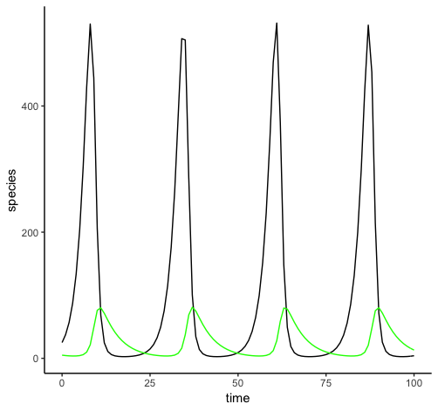

b

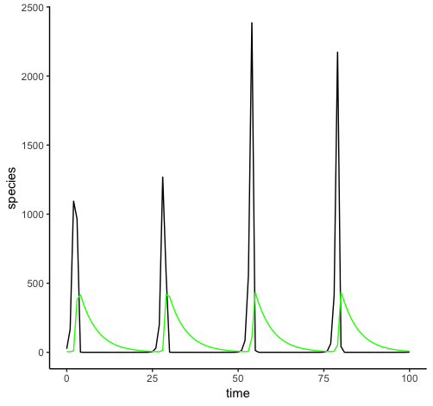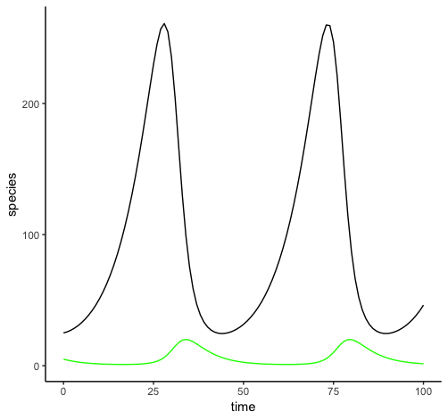

a

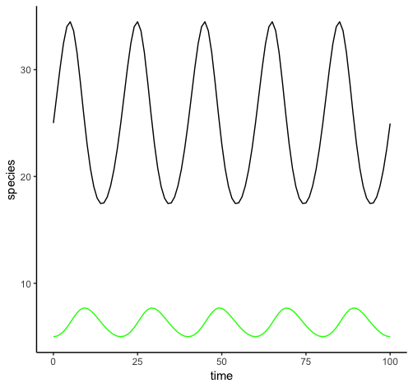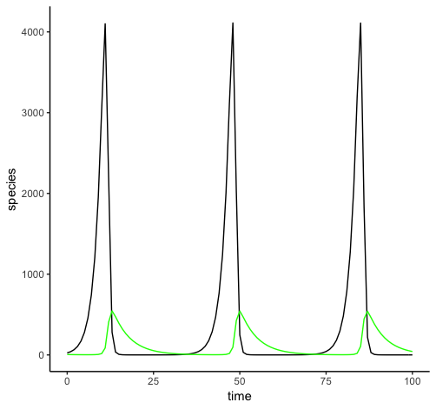

e

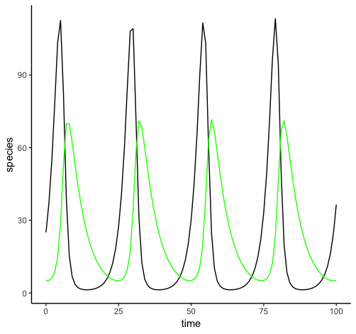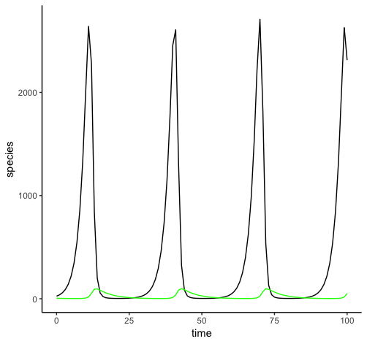

s

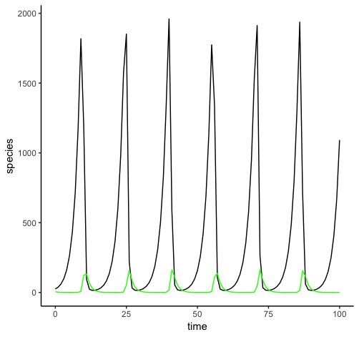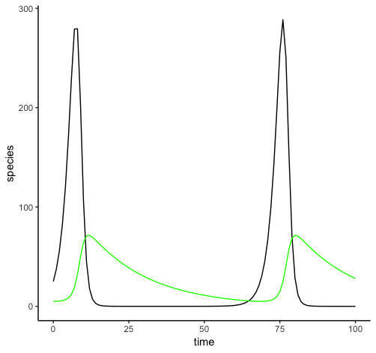

This model differs majorly from the Lotka-Volterra model mostly because there are many scenarios in which the two species do not follow a boom-bust cycle, and rather one of the two species outcompetes the other and the two populations become stable. This is true of the initial conditions. When b is changed, the populations still diverge in both cases. With high values of b, the resulting predator population is lower than in the initial case, and the prey population shoots up before coming down to roughly the original. At low values of b, prey population plummets, and predator population with it, until the predator population is so low that the prey population eventually settles around 500.

This is the only parameter where no change leads to a cycle occurring. Each other variable followed a pattern where either increasing or decreasing the value of the variable led to cycles occurring, while the other would lead to divergence.

For a, increased values led to divergence, with predator populations dropping to 0 after increased prey self-limitation led to a sharp decrease in herbivore population. Decreased self -imitation allowed prey population to climb and led a cyclic pattern where prey population size climbs up to 4000 before dropping to near 0 and then resetting.

For high values of d, the predator population dies too fast for a cycle to establish itself, so the predators die out while the herbivores reach carrying capacity fairly quickly. Lower values of d cause a cycle with a slightly longer period than the a cycle, and with about ¼ of the population size.

For e, it is the low values that lead to divergence. If prey is not efficiently converted to predators, the predator population reaches zero while the prey population, after dipping a bit early, reaches saturation. Increased conversion rates lead to a cycle with very rapid periods, and lower max populations than either of the previous two cycles.

Increasing predator death rate obviously causes predator population to decline and eventually leads to extinction of that species. Decreasing the value of s leads to a cycle with a relatively short period occurring, and the population sizes fluctuate around similar values to the initial case.

When the prey saturation factor is decreased, the populations quickly diverge as in the other cases. Increasing the value of the saturation factor creates periodicity and very short cycle times.

Predators only become abundant in cases where the two species coexist, in all cases (except for altered b values) when the populations did not coexist, the predator species went extinct.

As carrying capacity increases for the ecosystem, the prey population increases significantly, while the predator population stays relatively constant, despite the increase of carrying capacity. The reason for this is likely the same for why the predator population crashes in many of the other cases. If the prey population gets too large, the predator population increases to an unsustainable level and overconsumes the prey. When the prey population inevitably plummets, the predator population necessarily plummets in response, and is unable to recover. The prey population is able to recover however and therefore completely fills the ecosystem.